The combination of similarities and differences make southern Appalachia a biodiversity hotspot, with many niche ecosystems endemic to a specific region.
Materials and Methodologies
Data
This study focuses on the 8 national forests and 2 national parks located in southern Appalachia, which are the following: Chattahoochee-Oconee, Cherokee, Nantahala, Pisgah, George Washington-Jefferson, Daniel Boone Monongahela, and Wayne National Forests, and Great Smoky Mountains and Shenandoah National Park. The southern Appalachian region, which is located across many southeastern and eastern United States, is famously characterized by ancient mountainous regions, rolling foothills, and ridges and valleys. Furthermore, the region has a plethora of available water sources and is classified as a temperate rainforest, with Nantahala National Forest being ranked as the second wettest region in the continental United States behind the Pacific Northwest. The region’s temperate classification has contributed to the biodiversity of the region. For example, the Great Smoky Mountains National Park is a renowned biodiversity hotspot, with over 1,300 native plant species present and forest ecosystems endemic to this region and a variety of forest types present (Table x).
Data for this study comes from the Forest Inventory and Analysis long-term forest monitoring program, which serves as the United State’s national forest inventory. This inventory contains repeated plot measurements (5-7 years intervals in the Southeast) with each plot containing four fixed-radius subplots (7.3-m/24-ft radius), with all trees with diameter at breast height (DBH) greater than or equal to 12.7 cm or 5 in. is recorded. Four fixed-radius microplots (2.1-m/6.8-ft) are nested within each subplot, and trees with DBHs between 2.54-cm (1-in.) and 12.7-cm (5-in.) are recorded. The entire plot is divided up based off site condition classifications, like land use, ownership, forest type, stand size, and more. A plot can fall entirely in one distinct condition or be divided into multiple condition classes that run across the subplot and microplot boundaries. Because of the similarities within a condition class, the condition class was treated as the sampling unit and is subsequently referred to as “stand-level”.
To select data for this study, forested FIA plots that are located within the federal land boundaries are queried from the database. Extreme outliers were removed from the dataset which met the following conditions: diameter at breast height greater than 40 cm and carbon/hectare greater than 250 MgC/ha. The remaining total of 9,152 observations across all study sites to be used in the analysis.
Because of the spectrum of forest types presented across the various study regions, a random effect variable added on the FIA forest type classification. This allows model flexibility to account for various growth rates between the as the forest type allows for flexibility in the response variable from varying carbon growth among the various forest stands. T
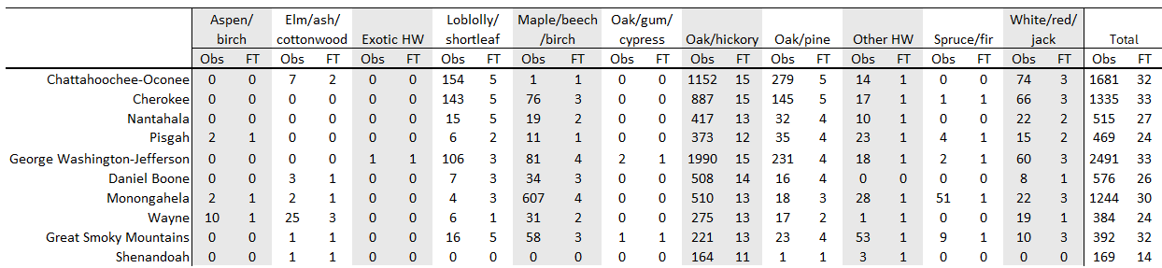
The FIA dataset primarily consists of oak-hickory mixed-hardwood forests but also capture the unique spruce-fir forests in the Great Smoky Mountains and aspen groves in Wayne. Can see the Smokies spruce fir forest and wayne’s aspen birch forests captured in this study. T Table [observations and forest type table]. presentAs seen in Table [observation and FT count table], the Smokies’ threatened spruce-fir forests are. Within the Smokies, the variation in elevation contributes to the plethora of biodiversity present, from montane alpine forests to lower elevation mixed hardwood forests. These upper montane forests have created critically endangered (? Too loaded of a term to use) While our regions of interest have many shared characteristics, each region also has its unique qualities. Wayne National Forest, located in southern Appalachia, is located solely in the foothills and is absent of the mountainous regions.
As the areas of interest are federally managed lands, these areas are less intensely managed compared to privately-owned lands, and the data collected from these areas represent the upper limits of tree and stand level qualities, like diameter, carbon, and so on.
Forest types
Forest type classification for the data used is determined via Burrill et al. (2024) algorithm. While a variety of forest types are present across the regions (45 distinct forest types), all study sites are primarily classified as Oak/Hickory forests, followed by Oak/Pine and Loblolly/Shortleaf Pine, as shown in Table [.]
FIA Long-term Permanent Plots and Tree Data
To study the federal lands located in southern Appalachia, we used data from the FIA’s permanent national forest inventory plots located within our regions of interest. These plots are re-inventoried every 5 to 7 years. Stand-level variables are calculated…
Environmental data
The WorldClim BIO variable dataset was used to provide environmental data for this study. This dataset was chosen due to the time availability, from (the early 2000s), and the 19 temperature and rainfall variables, which provides a comprehensive picture of the environmental conditions that the forests of this study developed under. Plus, the spatial resolution of (__ m.) is compatible with the FIA permanent plot size. Data was queried using the skiba Python application, using the entire time availability and FIA private plot coordinates.

Modeling Approaches
Three models were tested in this study. Two models were tested strictly for prediction performance, linear mixed-effects model and generalized-additive mixed model, and the third for interpretability (LASSO). Each model was fit with the stand-level variables alone and with combined stand and environment variables.
The linear mixed-effects model (LME) was built as the following:
$$C=\sum{xβ}+b+ϵ$$
$\sum{xβ}$ is the linear combination of predictors $x$ and their coefficients $β$, $b$ is a forest-type-specific random effect, and error term $ϵ$. We assume that $b$ follows a normal distribution with forest-type-specific variance $σ_{forty}^{2}$ ($b\sim N(0,σ_{forty}^{2}$)), and $ϵ$ follows a normal distribution with mean zero and variance $σ^{2}$ ($ϵ\sim N(0,σ^{2}$)). The ”lmer” function from the lme4 R package was used to fit this model

The generalized additive model was built as the following:

The LASSO model was built as the following:

Model Building and Evaluation Statistics
Each modeling approach and variable group (stand only and stand+environmental) were built using 1,000 cluster bootstrap sample to determine model performance and quantify model uncertainty. Because of the repeated plot measurements, potential temporal autocorrelation was accounted for by splitting training and testing datasets (also referred to as in-bag and out-of-bag data) on the sampling unit. Using this approach, if a plot condition is sampled in the training dataset, all repeated measurements for that plot condition are grouped into the training dataset and will not be included in the testing dataset. Likewise, data included in the testing dataset will not have been used in the training dataset. As a specific example, if sampling unit A was selected for the in-bag data, its measurements in 2012, 2017, and 2022 are all in the in-bag data. Sampling unit B was selected for out-of-bag data, then its measurements in 2008, 2013, and 2018 are all in the out-of-bag data. For each bootstrap sample, R², mean bias (MB), and root mean square error (RMSE) were calculated for the in-bag and out-of-bag data using the following equations:
$$R^{2}=1-\frac{\sum{\left(e^{2}\right)}}{\sum{{\left(C-\overline{C}\right)}^{2}}}$$
$$MB=\frac{\sum{\left(e\right)}}{n}$$
$$RMSE=\sqrt{\frac{\sum{e^{2}}}{n}}$$

$\overline{C}$ is the mean of $C$, $e=C-{\hat{C}}_{final}$, and $n$ is the total number of observations. Once the 1,000 bootstrap sample were trained, the median and 95% confidence intervals evaluation statistics were computed. In addition, for the LASSO models fit, coefficients of the fixed-effect variables were extracted from each bootstrap sample, and the median and 95% confidence intervals were calculated to determine significant predictors.
To visualize model fit, one out-of-bag sample for each study area was used to plot predicted vs observed carbon values. A 1:1 diagonal line and LOESS smoothing curve with 95% confidence interval were added, using the ggplot2 R package.

Random thoughts:
Materials sounds too much like yang paper.

